Project Design Phase-II
Data Flow Diagram & User Stories

Project Name | Cosmetic Insights : Navigating Cosmetics Trends and Consumer Insights with Tableau
Maximum Marks | 4 Marks

Data Flow Diagrams:
A Data Flow Diagram (DFD) is a traditional visual representation of the information flows within a system. A neat and clear DFD can depict the right amount of the system requirement graphically. It shows how data enters and leaves the system, what changes the information, and where data is stored.

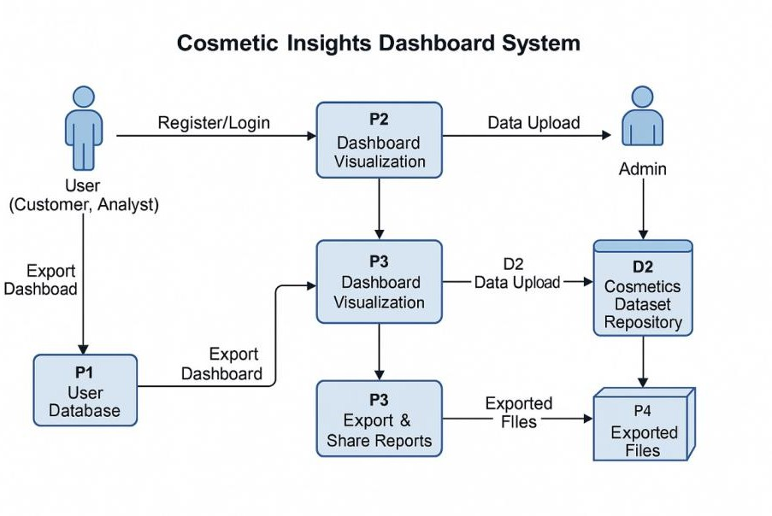

User Stories
Use the below template to list all the user stories for the product.

User Type | Functional Requirement (Epic) | User Story Number | User Story / Task | Acceptance criteria | Priority | Release
Customer (Mobile user) | Registration | USN-1 | As a user, I can register for the application by  entering my email, password, and confirming my password. | I can access my account / dashboard | High | Sprint-1
Customer (Mobile user) | Registration | USN-2 | As a user, I will receive confirmation email once I have registered for the application | I can receive confirmation email & click confirm | High | Sprint-1
Customer (Mobile user) | Registration | USN-3 | As a user, I can register for the application through Facebook | I can register & access the dashboard with Facebook Login | Low | Sprint-2
Customer (Mobile user) | Registration | USN-4 | As a user, I can register for the application through Gmail | I can register & login using my Gmail credentials | Medium | Sprint-1
Customer (Mobile user) | Login | USN-5 | As a user, I can log into the application by entering email & password | I am logged in &  redirected to the main dashboard | High | Sprint-1
Customer (Web user) | Dashboard | USN-6 | As a user, I can view cosmetic product trends by brand, region, and category on a dashboard | I can filter and explore visual trends using Tableau dashboards | High | Sprint-2
Customer (Web user) | Insights Export | USN-7 | As a user, I can export dashboard insights as PDF or Image for offline analysis | I can download/export charts and visuals in various formats | Medium | Sprint-2
Customer Care Executive | Consumer Insights | USN-8 | As a care executive, I can view user behavior metrics to understand customer preferences | I can see key behavior  KPIs like product views, likes, ratings | Medium | Sprint-2
Administrator | Data Upload | USN-9 | As an admin, I can upload new datasets (Excel, CSV) into the Tableau dashboard | The new dataset is processed and reflected in the updated dashboard | High | Sprint-1
Administrator | Access Control | USN-10 | As an admin, I can manage user roles and permissions (viewer, editor, admin) | I can assign or revoke dashboard access levels | High | Sprint-1

